**Name: Steven Peng**

**Group: Technology Committee**

Ie. Technology Committee, Legends, etc

**Date: 3/30/2021**

**Total Amount Requested: $294.43**

**Please list the items you request for funding in order of priority from most essential to least essential. Expenditures at the top should be those whose funding is most essential to the organization.**

**\*\*WHEN PROVIDING A PRICE ESTIMATE, PLEASE INCLUDE TAX AND SHIPPING TO HELP OVERESTIMATE THE COST\*\***

|  |  |  |  |  |  |  |
| --- | --- | --- | --- | --- | --- | --- |
| **ITEM** | **PURPOSE** | **DATE YOU NEED THIS ITEM BY (LATEST)** | **QUANTITY** | **UNIT PRICE** | **TOTAL AMOUNT REQUESTED (PRICE x QUANTITY)** | **OVERESTIMATION NOTES (DID YOU CHOOSE A MORE EXPENSIVE PART/INCREASE SHIPPING? BY APPROX HOW MUCH?)** |
| **iMac 21.5” Adhesive Strips** | **Required to repair the iMac** | **4/20** | **2** | **7.48** | **14.96** | **Tax included in unit price** |
| **iMac 27” Adhesive Strips** | **Required to repair the iMac** | **4/20** | **1** | **7.48** | **7.48** | **Tax included in unit price** |
| **Car battery USB hub** | **Charge devices at the track or other events.** | **4/20** | **1** | **15.78** | **15.78** | **Tax included in unit price** |
| **Bluetooth Receiver** | **Play music from phone** | **4/20** | **3** | **8.94** | **26.82** | **Tax included in unit price** |
| **5m, 150 RGB LED Strip (Non Waterproof)** | **Lights up shelving in storage units** | **4/20** | **1** | **20.13** | **20.13** | **Tax included in unit price** |
| **2 Pack of ESP32 Microcontrollers** | **Controls the LEDs in the RGB strip** | **4/20** | **1** | **15.89** | **15.89** | **Tax included in unit price** |
| **2.5” SSD** | **Used to refurbish old computers for the team room** | **4/20** | **4** | **29.95** | **119.80** | **Tax included in unit price** |
| **SSD Mounting Bracket** | **Used to refurbish old computers for the team room** | **4/20** | **1** | **6.41** | **6.41** | **Tax included in unit price** |
| **Printer Ink** | **For the printer used to print technical documents for competitions and engineering purposes** | **4/20** | **1** | **36.37** | **36.37** | **Tax included in unit price** |
| **Printer Paper** | **For the printer used to print technical documents for competitions and engineering purposes** | **4/20** | **1** | **30.79** | **30.79** | **Tax included in unit price** |

**How does each requested expense support the mission of the organization? Please be specific and answer regarding *each line item*. (Every item needs to have a description for why you need it. At least 2 sentences per item.)**

**iMac 21.5” Adhesive Strips**

The iMac 21.5” Adhesive Strips are needed in order to successfully replace the hard drive in the iMac to make them usable again. This is a great educational opportunity for hardware repair on a more challenging platform.

**iMac 27” Adhesive Strips**

The iMac 27” Adhesive Strips are needed in order to successfully replace the hard drive in the iMac to make them usable again. This is a great educational opportunity for hardware repair on a more challenging platform.

**Car battery USB hub**

The car battery USB hub will be essential for outside events where we don’t have access to outlets. With a car battery, we’ll be able to power devices or charge them if needed.

**Bluetooth Receiver**

It’s important to create a conductive work environment at Lacy hall and at outside events, and being able to play music at appropriate times can help create that environment. The receiver can also be used to relay recorded audio instructions in addition to boosting team morale.

**5m, 150 RGB LED Strip (Non Waterproof)**

The RGB LED Strip will be used to light up the storage and shelving areas of the workspace. In contrast to regular Christmas or fairy lights, each LED is individually addressable through a microcontroller, which represents a great educational opportunity to expose more members to basic concepts in programming and signal processing.

**2 Pack of ESP32 Microcontrollers**

The 2 pack of ESP32 Microcontrollers will be used to control the LED Strip lighting up the storage and shelving areas of our workspace. The microcontrollers will be used to individually control and program each LED, allowing members to gain more experience working with programming and signal processing.

**2.5” SSD**

The SSD will be used to upgrade our old computers we have available for members to use, which will provide a hands on learning experience on how to upgrade an old computer along with managing the installation of the OS. Without the SSDs, the computers will be slow and remain unusable.

**SSD Mounting Bracket**

The SSD mounting brackets are required to properly install the new SSDs into our old machines to make them usable again, which is a great learning opportunity for upgrading old equipment to make them useable again. Without these brackets, the SSDs cannot be installed properly and risk damaging internal components of the computer.

**Printer Ink**

Printer ink will be used to print out technical documents and forms required for SAE competition. Without ink, we would not be able to print out the required forms and would not be able to compete.

**Printer Paper**

Printer paper will be used to print out technical documents and forms required for SAE competition. Without paper, we would not be able to print out the required forms and would not be able to compete.

**Please list below all links to invoices and price quotes. You may use photographs, scans, or screenshots instead if it conveys the price quotes better (ie. if the link is to more than one item/ the website is just an order form), but make sure to also include the link.**

**5m, 150 RGB LED Strip (Non-waterproof)**

[**https://www.ebay.com/itm/203299772642**](https://www.ebay.com/itm/203299772642)

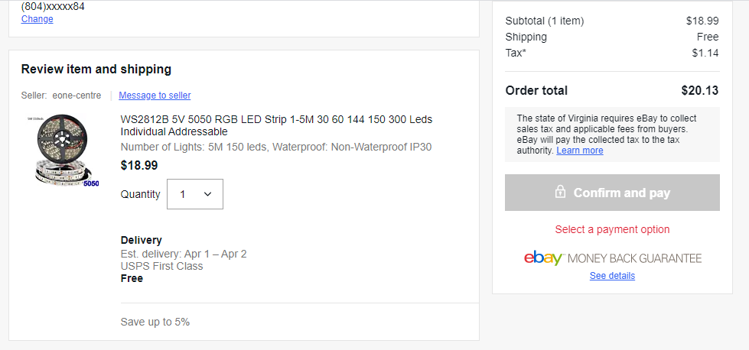

**iMac 27” Adhesive Strips**

[**https://www.amazon.com/dp/B088YMXSR4/**](https://www.amazon.com/dp/B088YMXSR4/)

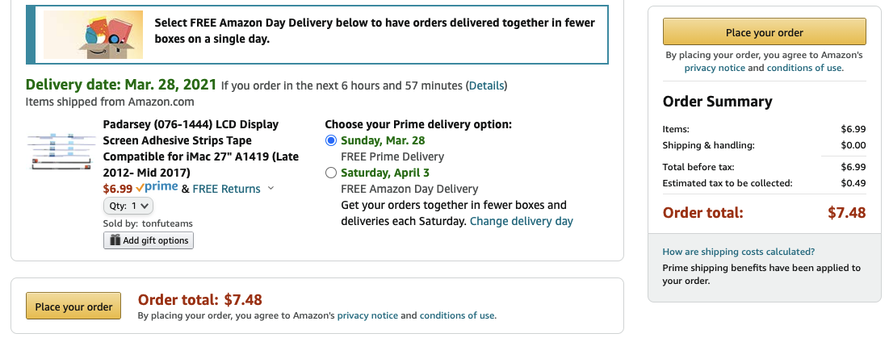

**iMac 21.5” Adhesive Strips**

[**https://www.amazon.com/dp/B08L1166KZ/**](https://www.amazon.com/dp/B08L1166KZ/)

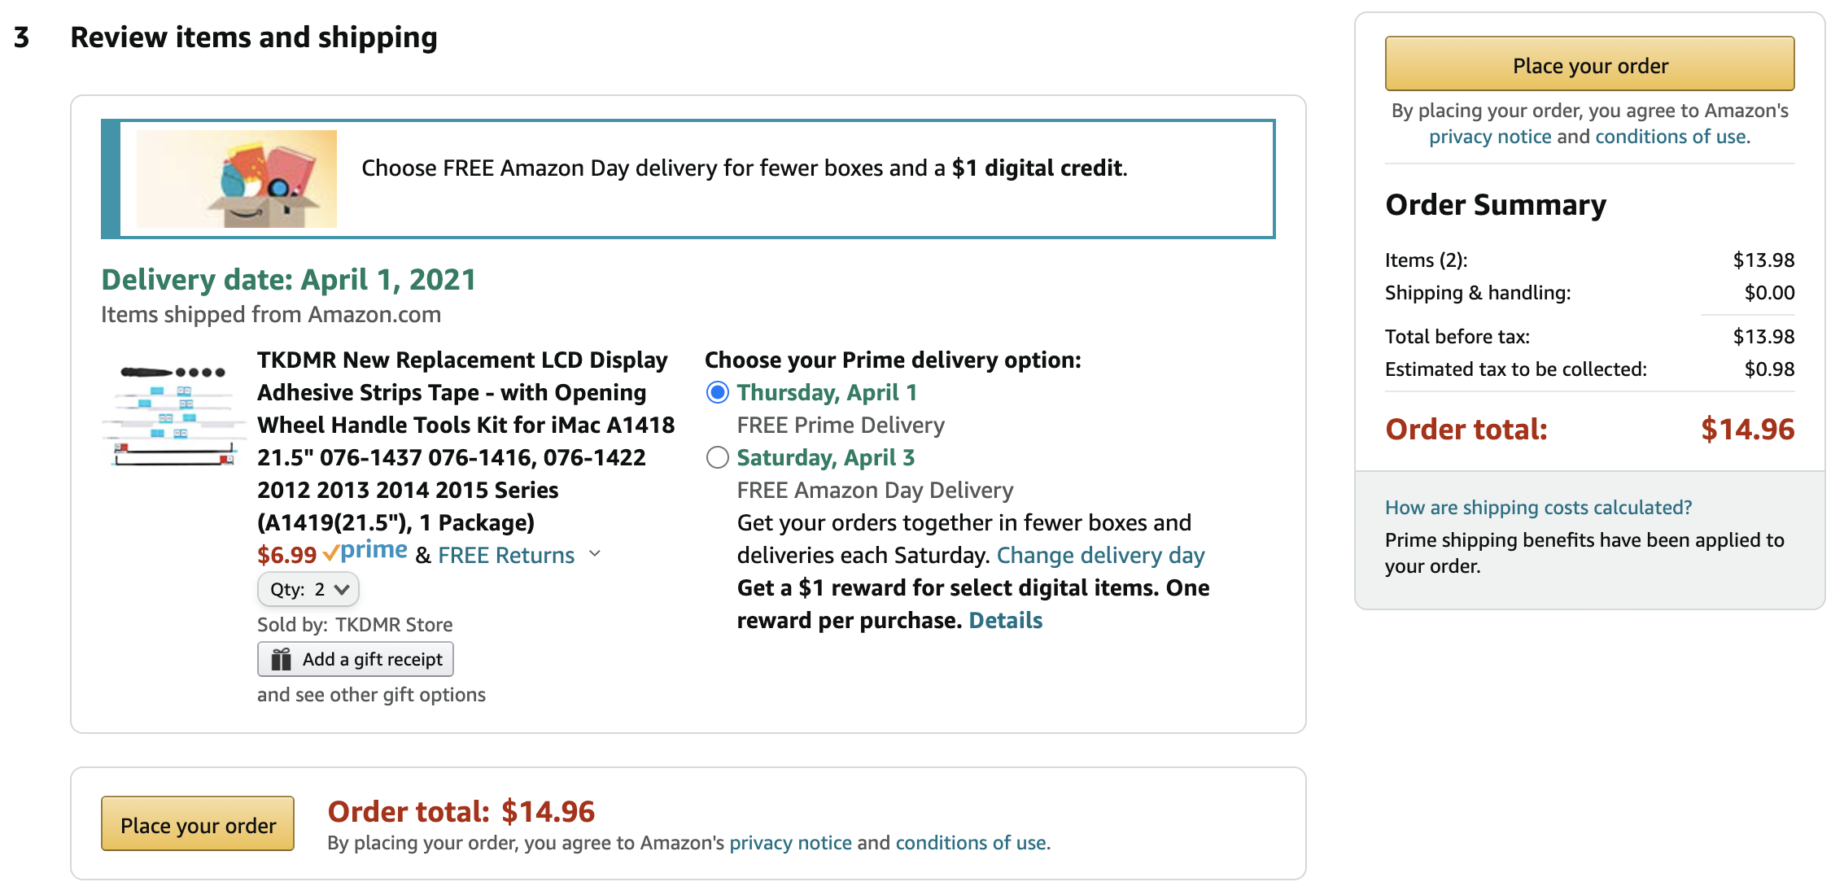

**Car Battery USB Hub**

[https://www.amazon.com/dp/B08MCZNYZN](https://www.amazon.com/Converter-Battery-8A-Regulator-Suitable/dp/B08MCZNYZN/ref=pd_vtp_12?pd_rd_w=yV4JB&pf_rd_p=5c360d95-bc02-444b-9d6e-b8f4fe9d33b5&pf_rd_r=XKVMBW6TD782C4HNSXJR&pd_rd_r=0c85bf48-9585-4bf0-8a10-c86e4d8d5424&pd_rd_wg=ctGkA&pd_rd_i=B08MCZNYZN&psc=1)

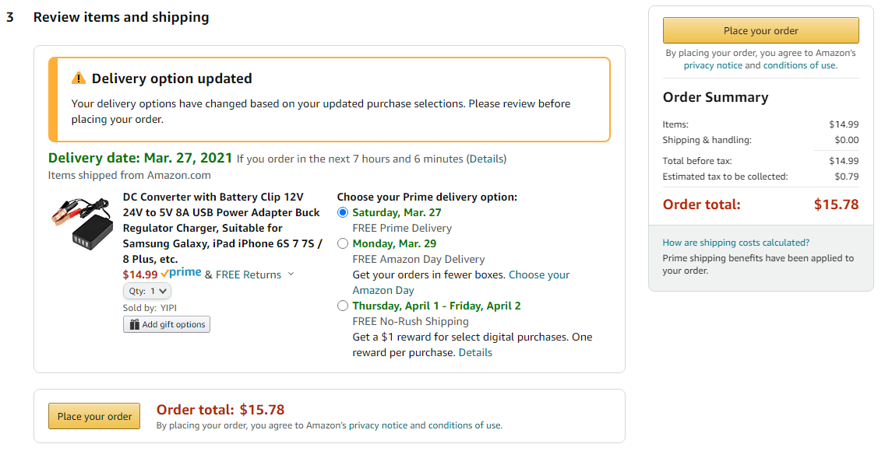

**Bluetooth Receiver**

[https://www.amazon.com/dp/B07TCDS2JB/](https://www.amazon.com/Bluetooth-Boltune-Headphones-Hands-Free-Microphone/dp/B07TCDS2JB/ref=psdc_1293687011_t2_B08MJ96WK4)

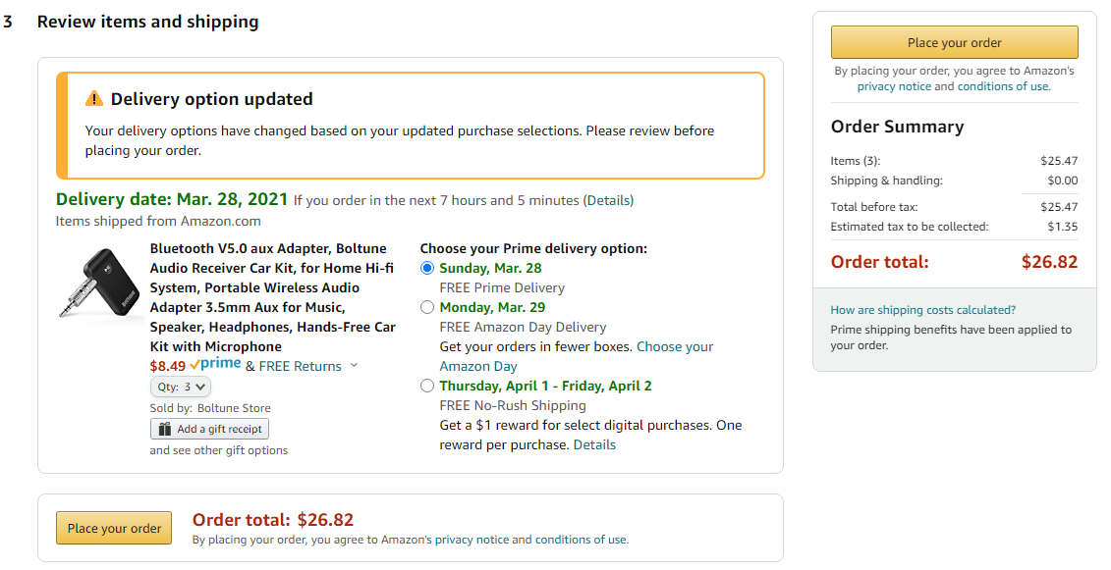

**ESP32 Microcontroller**

[**https://www.amazon.com/dp/B07Q576VWZ/**](https://www.amazon.com/MELIFE-Development-Dual-Mode-Microcontroller-Integrated/dp/B07Q576VWZ/ref=sr_1_6?dchild=1&keywords=esp32&qid=1616704458&s=electronics&sr=1-6)

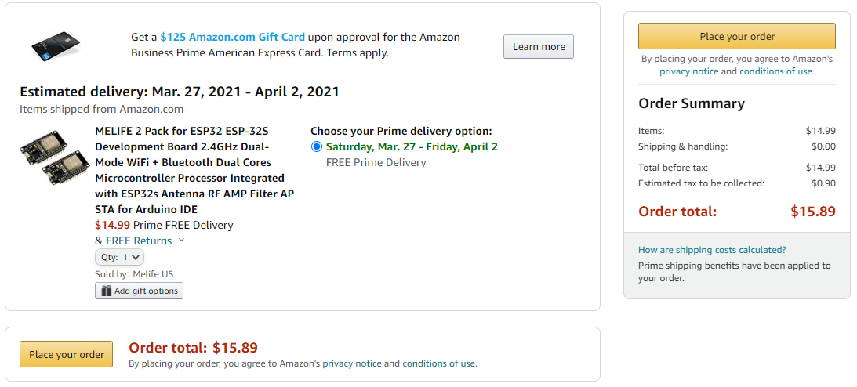

**2.5” SSD**

[**https://www.amazon.com/dp/B0722XPTL6/**](https://www.amazon.com/dp/B0722XPTL6/)

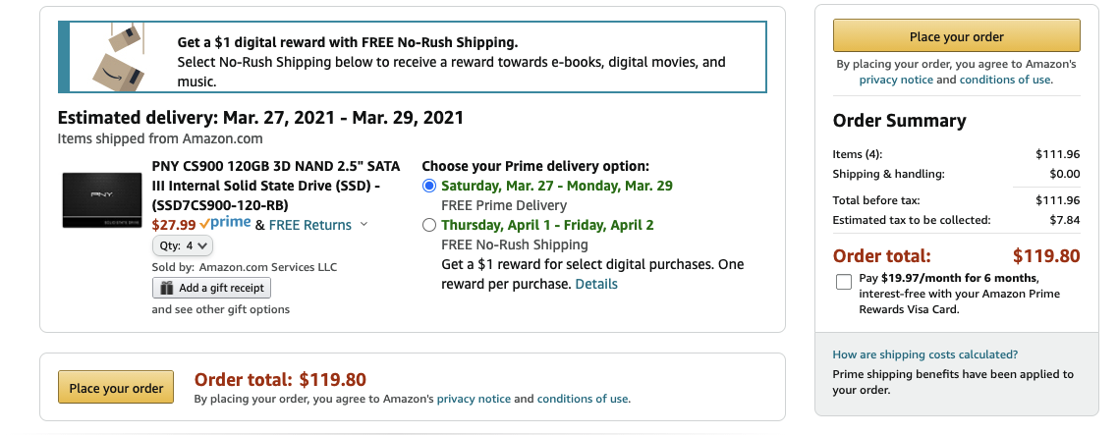

**SSD Mounting Bracket**

[**https://www.amazon.com/dp/B0183FSG68/**](https://www.amazon.com/dp/B0183FSG68/)

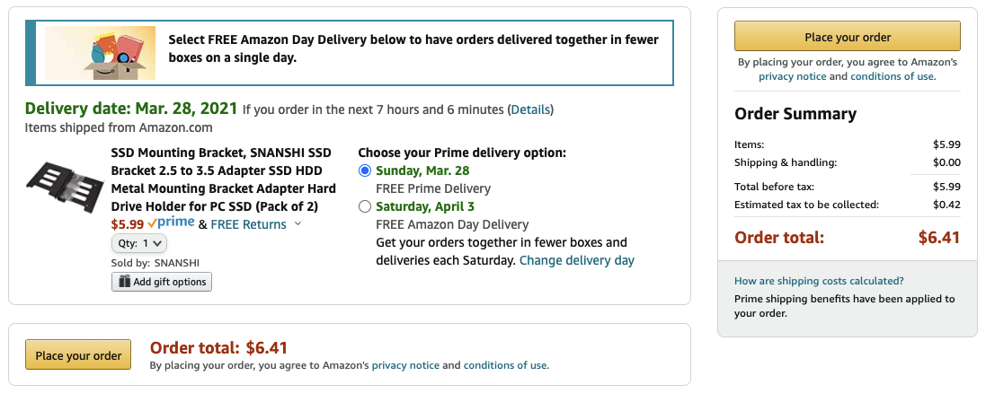

**Printer Ink**

[**https://www.amazon.com/dp/B01BYAVC9W/**](https://www.amazon.com/dp/B01BYAVC9W/)

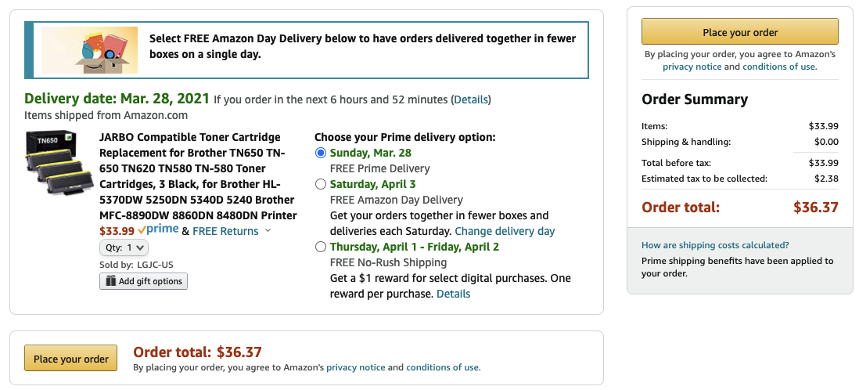

**Printer Paper**

[**https://www.amazon.com/dp/B072FVQNWM**](https://www.amazon.com/dp/B072FVQNWM)

